1201 Wesleyan St. | Fort Worth, TX 76105 | 817-531-4444 | txwes.edu
SAMPLE TITLE HERE

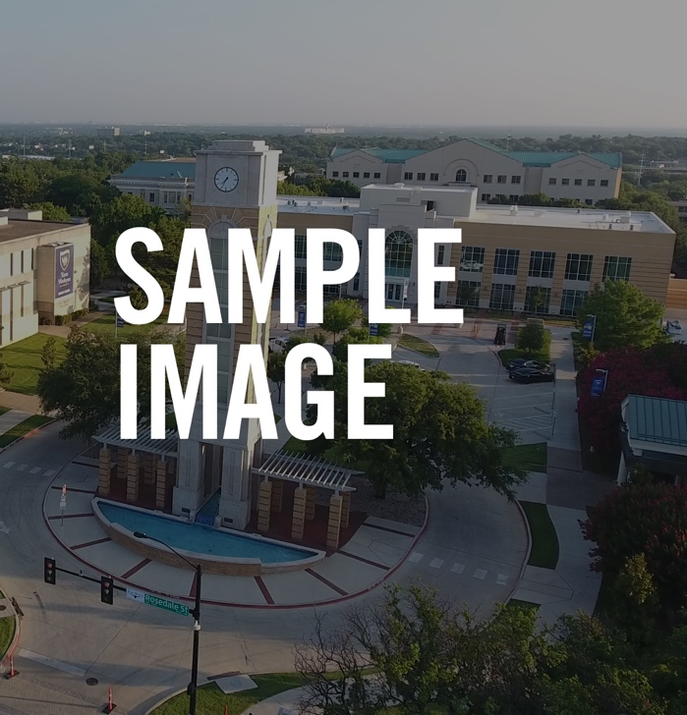
Sample Subtitle Here

Event Details Aug. 23
11 a.m. - 1 p.m. Location

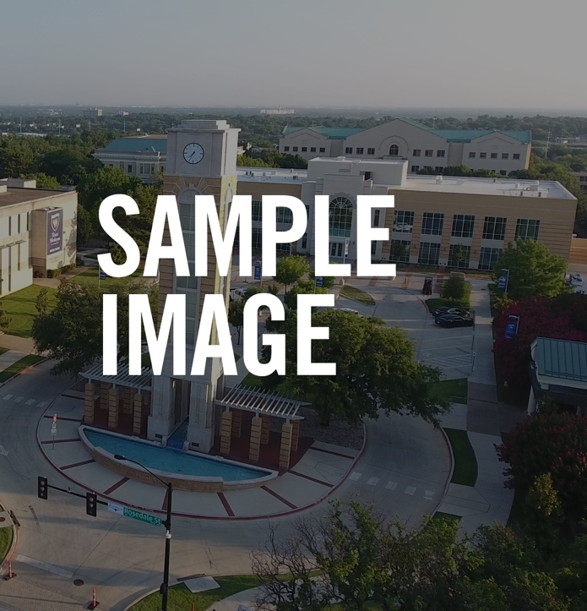
More event details could go here if needed. More event details could go here if needed. More event details could go here if needed. More event de- tails could go here if needed. More event details could go here if needed.
More event details could go here if needed. More event details could go here if needed. More event details could go here if needed. More event de- tails could go here if needed. More event details could go here if needed.

QUESTIONS?
Contact us at 817-531-4444 or info@txwes.edu

TXWES.EDU

