1201 Wesleyan St. Fort Worth, TX 76105
817-531-4444
txwes.edu

SAMPLE TITLE HERE
Sample Subtitle Here

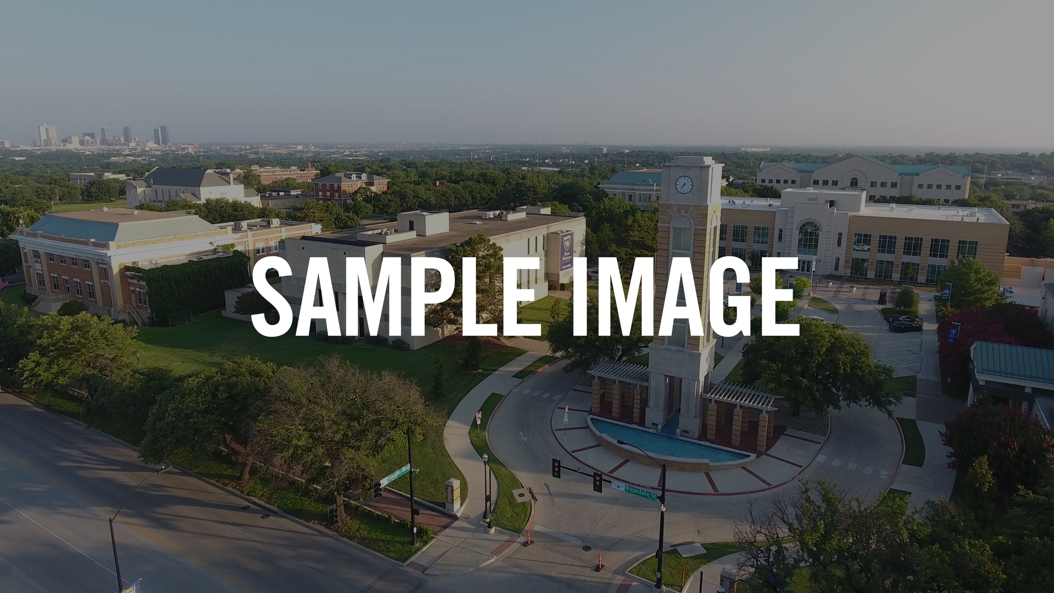

Event Details AUG. 23 | 11 AM - 1 PM
LOCATION

More event details could go here if needed. More event details could go here if needed. More event details could go here if needed. More event details could go here if needed. More event de- tails could go here if needed.

TXWES.EDU

QUESTIONS?
Contact us at 817-531-4444 or info@txwes.edu

